After Effects Project 2 S.E.T.
S
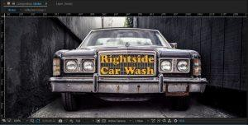
cenario: The owners of the Rightside Car Wash need a 5 second commercial that they can post on their Facebook group and give to the local theater for the
spacer between movies. They will provide you with an image of a cool old car in an alley way.

xpectation: Learn how to setup an After Effects CC project, work with the opacity transformation keyframes and work with text animations.
E

T imeline: This may take a student 3-4 hours of class time to complete.
Paste your test results here!

After Effects Project 2 Worksheets
NOTES: Using the BrainBuffet Project 2 tutorials, please answer the following questions.
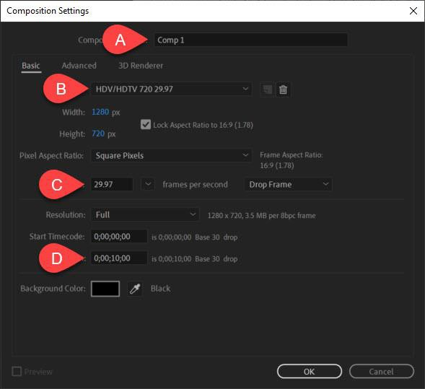

- Use the diagram above to name and describe the composition settings
 | Name | Description
A.
B.
C.
D.

- List two ways to change the composition settings once you have created a comp. a.
b.
- What are some common pre-production documents used for working with clients and planning a project?
a.
b.
c.
d.

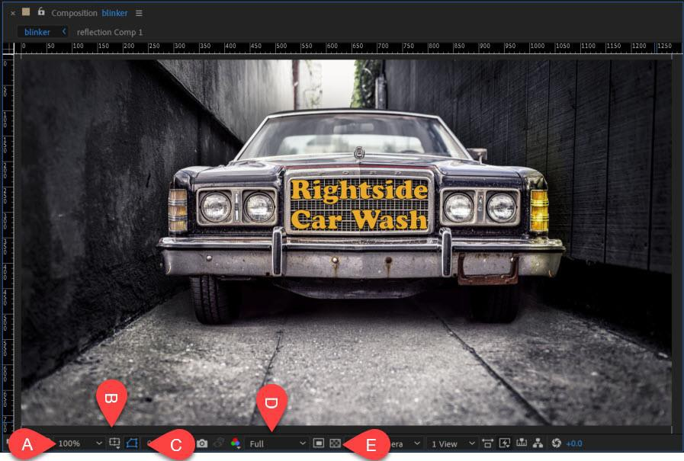

- Use the diagram above to name and describe the function of these key composition panel buttons
 | Name | Description
A.
B.
C.
D.
E.

- How can you fix a broken link to a file when you accidently rename, move or delete a file that has been imported into After Effects?
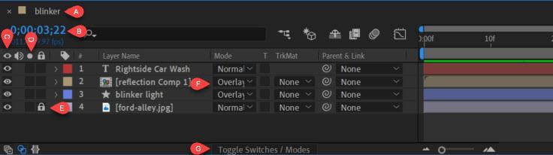

- Use the diagram above to name and describe the function of these key composition panel buttons
 | Name | Description
A.
B.
C.
D.
E.
F.
G.

- What do you need to do to create a shape layer instead of a mask?

- What are the keyboard shortcuts for the transformation properties and keyframes?

Transformation | Letter

- What are a couple ways to create a keyframe? a.
b.
c.
- What is the keyboard shortcuts for this important functions?

Shortcut | Function
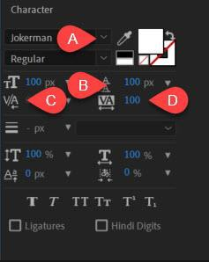
- Use the diagram above to name and describe the function of these key composition panel buttons
 | Name | Description
A.
B.
C.
D.

After Effects Project 2 Checklist and Rubric

PROJECT 2 SPECIFICATIONS
Rightside car wash video file:  - Should include animated blinker with reflection  - Animated text  - You have choice of colors, fonts and animation presets | Completed folder should have:  - Student Packet Project 2  - Rightside car wash video file | You should be able to:  - Animate the opacity keyframes for the blinker  - Create a reflection Pre-Comp  - Adjust the keyframes for the preset animation on the text  - Adjust the leading and tracking of text  - Export using the Render Queue

After Effects CC PROJECT 2 SCORING RUBRIC |  |  |  | Studen t Score
Mastery of | 10 points: | 7 points: | 4 points:
Skills | Student is able to  demonstrate abilities | Video only  demonstrates mastery | Few skills are  demonstrated.
 | according to | of some skills according
 | specifications. (video). | to specs.
Effort Level | 10 points: | 7 points: | 4 points:
 | Student packet is | Some issues with | Tutorial
 | completed accurately | student packet. | instructions were
 | and completely. |  | not followed completely.
Tutorials Completed | 5 points:  All tutorial videos have been completed. | 2 points:  Some tutorials have not been completed.
Total Points Earned
(25 points possible)

Extension Challenges:

Use your new motion graphics skills to create another 5 second animation that demonstrates the same concepts. Could be a first responder vehicle with flashing lights.

Cross-Curricular Enrichment:
  - Language Arts: Make a short commercial for a book report
  - Social Studies- Make a short-animated infographic for a historical event
  - Science/Technology- Make a short animation of an experiment

