After Effects CC18|19|20 Project 3 “Company Slogan”
cenario: In this project you will create a short text animation for Brain Buffet using their company slogan.
S

xpectation: Learn how to master the scale transformation and control the acceleration/deceleration of your animations using
E
easing and the graph editor. Then use the Adobe Media Encoder to export your project.

imeline: This should take you 2-4 hours of class time to complete.
T

PASTE TEST RESULTS HERE

After Effects Project 3 Worksheets
NOTES: Using the BrainBuffet Project 3 tutorials, please answer the following questions.
- Use the diagram above to name and describe the features in the After Effects workspace
 | Name | Description
A.
B.
C.

- Where do you change the grids and guides colors and size?

- What are two ways to change the location of the anchor point? a.
b.
c.

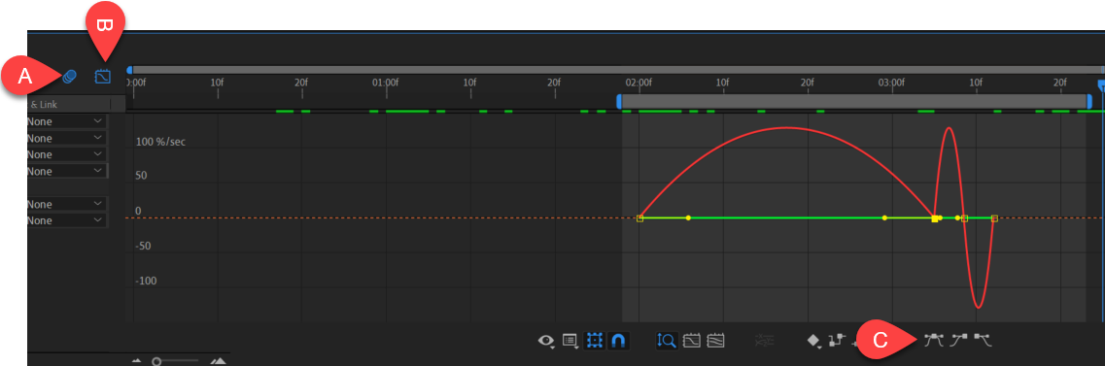
- Use the diagram above to name and describe the features in the After Effects workspace
 | Name | Description
A.
B.
C.

- What format does Joe recommend when exporting from the Adobe Media Encoder?

- Take a screen shot of your Project Panel and paste below.
.

Extension Challenges:
- Produce a ten second text-based animation for a sports team, club or community organization

Cross-Curricular Enrichment:
- Language Arts: Write a poem and then animate it
- Math- Animate the steps of a simple math problem
- Social Studies- Produce a text based commercial for a historical figure or organization from the past

