After Effects Project 4 S.E.T.
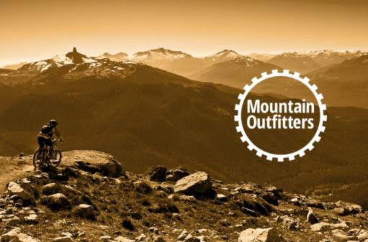
cenario: A local retailer, Mountain Outfitters, has asked us to create a 5 second animation that combines their logo and a photograph for their website.
S

xpectation: Learn how to apply and adjust effects, create shape layers from vector graphics and use the rotation transformation properties to animate a logo
E

imeline: This should take you 1-2 hours of class time to complete.
T
PASTE YOUR TEST RESULTS HERE

After Effects Project 4 Worksheets
NOTES: Using the BrainBuffet Project 4 tutorials, please answer the following questions.

- Fill in the panel name that matches the description.
Panel | Description
 | Browse or search for effects
 | Adjust or animate an effect that has been applied
 | Used to organize your media, compositions and solid layers
 | Used to organize your layers and add animation keyframes
 | Used to layout your design
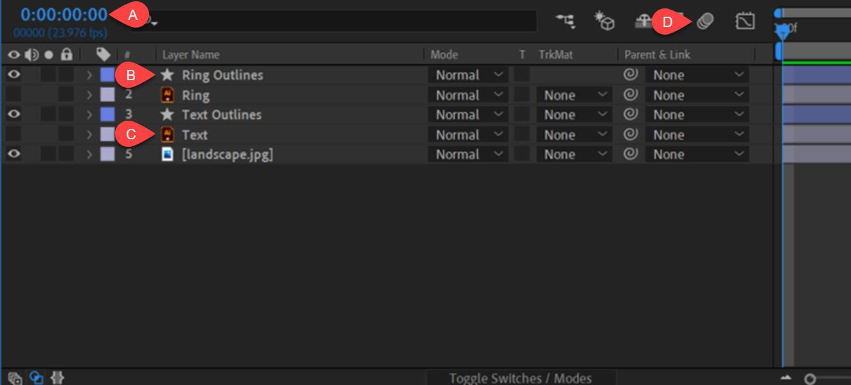
- Use the diagram above to name and describe the features in the After Effects timeline panel
 | Name | Description
A.
B.
C.
D.

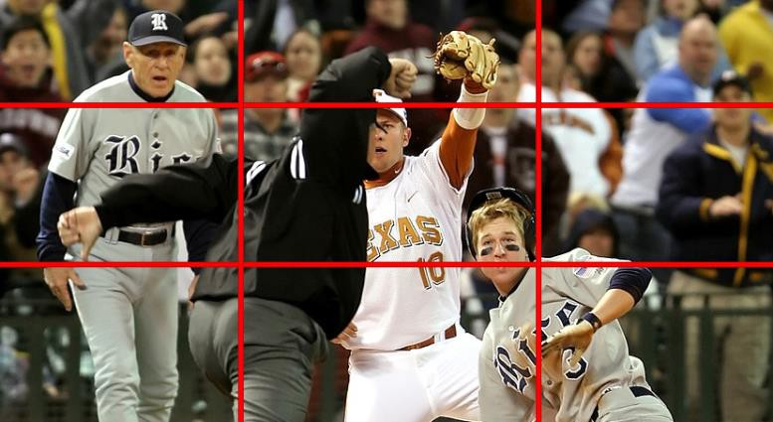
- What is the composition term illustrated in the image above? a.

- Use the diagram above to match name and describe for the rotation values

Description
Whole Rotation: Changing this number will make an entire rotation. It can be both a positive or negative number depending on the
direction of rotation.
Rotation Degrees: Changing this number will rotate the object in small increments or degrees adding up to 360.

- Add the keyboard shortcuts in the table below
Keyboard Shortcut | Function
 | Show rotation properties for the selected layer
 | Show rotation properties for the selected layer and add a Keyframe
Adjust the end of the work area to the location of the current
time indicator

- Create a screenshot of your layers in the timeline when you complete the project and place the image file in your project folder.

After Effects Project 4 Checklist and Rubric

Extension Challenges:
- Use a photo from a sport or a club and your school logo to create a short animation.

Cross-Curricular Enrichment:
- Social Studies- Produce a short animation for a historical figure’s website
- Language Arts: Write the copy for an advertisement that goes along with the animated logo you created.
- Math- Learn about the degrees that make up a full rotation
- Science/Technology- Research where the “Sepia” color came from in photography
Project 5 – Mount Baker

