After Effects Project 5 S.E.T.
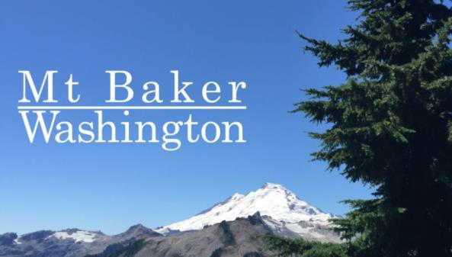
cenario: The Mt Baker Ski Area has hired you to make a short-animated title for them. They will provide you with the photograph. You will give them two different
S
options.

xpectation: Learn how to use guides, position animation techniques and working with track mattes.
E

imeline: This should take you 3-4 hours of class time to complete.
T

PASTE YOUR TEST RESULTS HERE

After Effects Project 5 Worksheets
NOTES: Using the BrainBuffet Project 5 tutorials, please answer the following questions.
- Use the diagram above to name the timeline controls and symbols (Yes, we did this last week too!)
Name
A.
B.
C.
D.
E.

On the second video (Animating with position) take a screenshot and paste below:

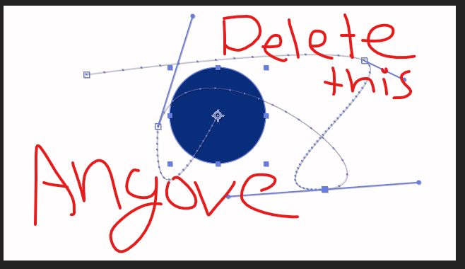

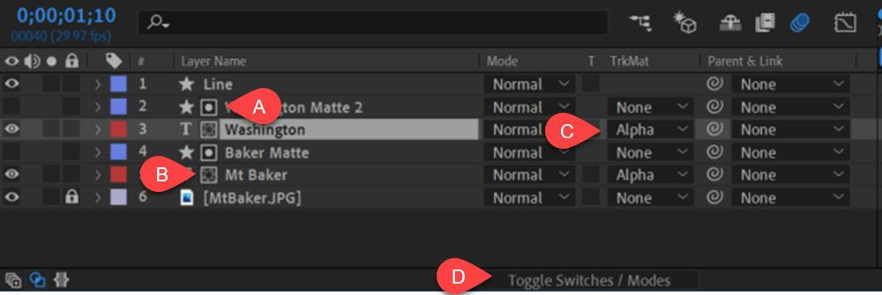
- Use the diagram above to name the timeline controls and symbols
 | Name |  | Name
A. |  | C.
B. |  | D.

- What are the following actions called?
Name | Definition
 | The change in space of a position keyframe (linear vs Bezier)
 | The change in time of a position keyframe (constant, acceleration/deceleration)
 | Guide for position or an animation over time
 | Name of the handles that allow you to bend a path

- Fill in the Keyboard Shortcuts
Keyboard Shortcut | Definition
 | Add media to the composition and center it
 | Speed up a transformation value change by a factor of 10
 | Jump to the previous/next keyframes
 | Reveal and add a position keyframe to the selected layer

