After Effects Project 6 S.E.T.
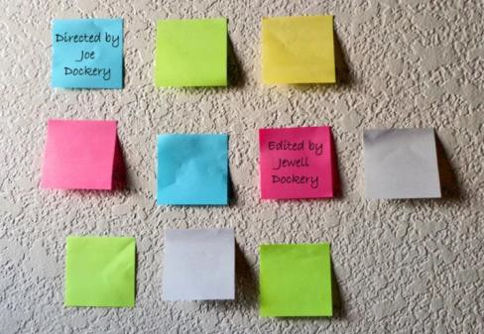
cenario: In this project you are going to create an animated credit sequence that zooms in/out of a bunch of sticky notes on a wall.
S

xpectation: Learn how to create a custom workspace and animate using a combination of scale and anchor transformations.
E

imeline: This should take you 2-3 hours of class time to complete.
T

PASTE YOUR TEST RESULTS HERE

After Effects Project 6 Worksheets
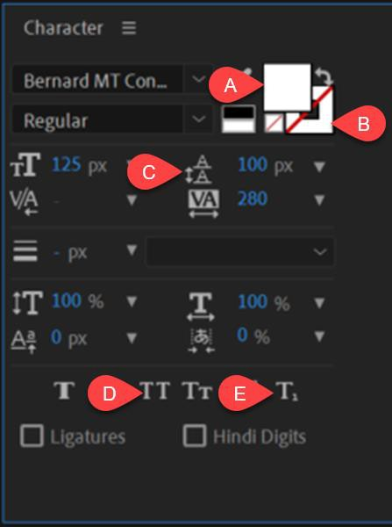
NOTES: Using the BrainBuffet Project 6 tutorials, please answer the following questions.

- Use the diagram above to name the Character panel Controls

Name
A.
B.
C.
D.
E.

- Define these Pre-Production tools:
Tool | Definition
Script
Storyboard
Shot List

- Write a short definition of each:
What is a “Workspace”?
How do you create a new custom workspace?
- What keyboard shortcut allows you to reveal another transformation property to a layer? a.

Extension Challenges:
- Use a photo and some text to make a short animation for your social media channel

Cross-Curricular Enrichment:
- Language Arts: Animate your vocabulary words over a photograph
- Social Studies- Make animated title slide for a report
- Science/Technology- Make animated title slide for a report

