After Effects Project 7 S.E.T.
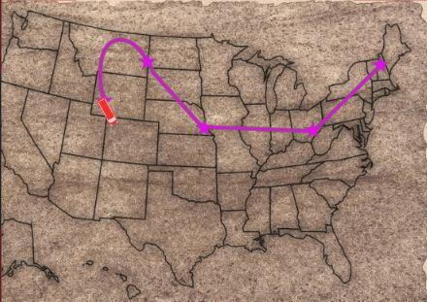
cenario: In this project you will create an animated travel map that highlights four destinations in the US. It is like the
S
animations used in the Indiana Jones films.

xpectation: Learn how to setup an After Effects CC project, apply and animate effects and a quick introduction to
E
expressions.

imeline: This should take you 3-4 hours of class time to complete.
T

PASTE YOUR TEST RESULTS HERE

After Effects Project 7 Worksheets
NOTES: Using the BrainBuffet Project 7 tutorials, please answer the following questions.

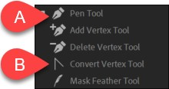
- Use the diagram above to describe the features in the After Effects workspace
Description
A.
B.

- How do you add more points to a star shape?

- Add the file extension that matches the description in the table below. Use the Quizlet to
study the ones that we haven’t covered in the lessons.
File Formats Quizlet: https://quizlet.com/_2ee00h?x=1jqt&i=pmv66
File formats
File extension | Description
 | Best file format for images with transparency because it contains thousands of levels of transparency
Best file format for photographs because it contains millions of colors and has efficient compression (no
transparency)
 | Uncompressed image file format, will make larger but higher quality images.
 | Adobe Photoshop file. This is a great option because of the tight integration of the Adobe applications.
 | Adobe Illustrator file. This is a great option because of the tight integration of the Adobe applications.
 | Adobe After Effects. This is a great option because of the tight integration of the Adobe applications.
 | An older video/audio file format (1992) that used to be the standard
 | A newer video/audio format with better compression so it has higher quality in a smaller file size
 | Windows media video
 | Windows media audio
 | This is a common file format for audio that uses compress to scale the file size
 | This is a uncompressed file format for audio that is commonly used in video editing
 | Vector graphic file format (Scaleable Vector Graphic)

- Use the diagram above to describe the features in the After Effects workspace
Description
A.
B.
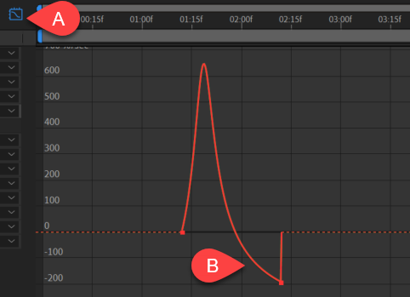
- Use the diagram above to describe the features in the After Effects workspace
Description
A.
B.

