After Effects Project 8 S.E.T.
cenario: The Mountain Outfitters company loved our first animation of their logo that they have asked us if we could
S
do a 3D animation now. First you will practice animating your name and then produce a quick 3D animation of their logo.

xpectation: Learn how to work with 3D layers to light and animate a 3D scene.
E
T imeline: This should take you 2-4 hours of class time to complete.

PASTE YOUR TEST RESULTS HERE

After Effects Project 8 Worksheets
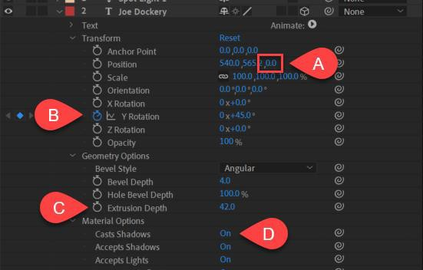
- NOTES: Using the BrainBuffet Project 8 tutorials, please answer the following questions.

  - Use the diagram above to name and describe the features in the After Effects timeline panel

 | Name | Description
A.
B.
C.
D.

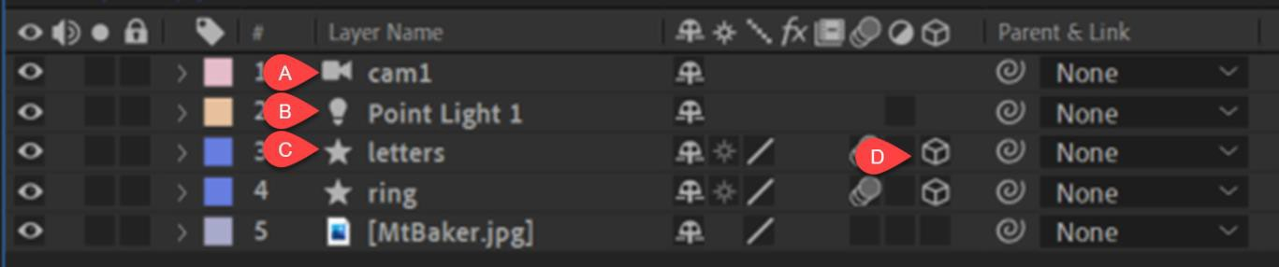
  - Use the diagram above to name and describe the features in the After Effects timeline panel
 | Name | Description
A.
B.
C.
D.

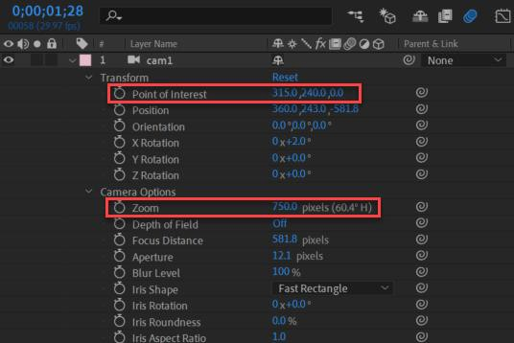
  - Use the diagram above to name and describe the features of a 3D camera in After Effects
 | Name | Description
A.
B.

Include a screenshot of your cameras Transformation and Camera options like the diagram above.

