After Effects Project 9 S.E.T.
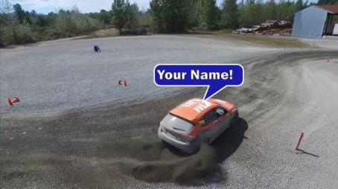
cenario: In this series of projects you will produce three examples of tracking and remapping for an action
S
sports client.

xpectation: Learn how to motion track an object to tie an animation to a moving object and use time remapping to control the speed, direction and freeze
E
video clips.
T imeline: This should take you 5-6 hours of class time to complete.
PASTE YOUR TEST RESULTS HERE

After Effects Project 9 Worksheets
NOTES: Using the BrainBuffet Project 9 tutorials, please answer the following questions.

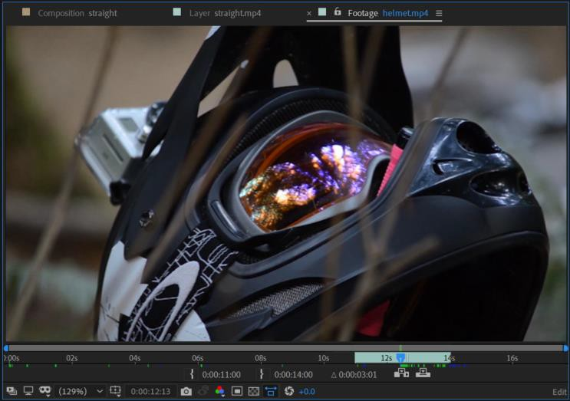
- Use the image above to fill in the values for the following items
In Point
Out Point
Overall length of the trimmed clip

- Describe the process of using the work area bar to shorten the duration of a composition
a.
b.
c.

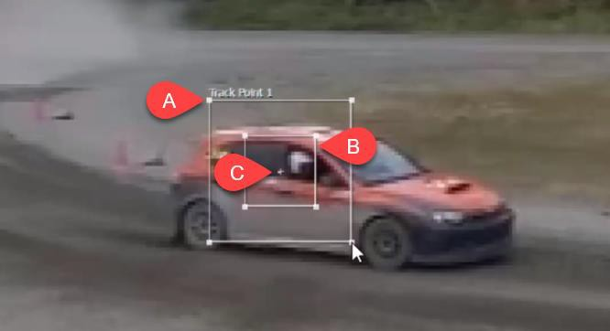
- Use the diagram above to label and describe the Motion Tracker Controls
 | Name | Description
A.
B.
C.

Check out: https://helpx.adobe.com/after-effects/using/tracking-stabilizing-motion-cs5.html

- How do you make a clip play in reverse?

- How do you freeze a clip? a.
b.
c.

