After Effects Project 10 S.E.T.
cenario: Jewell’s DJ services has asked you to produce a series of short video composites that she can use in her
S
promotional videos.

xpectation: Learn how to blend, key and mask video composites.
E

imeline: This should take you 3-4 hours of class time to complete.
T
PASTE YOUR TEST RESULTS HERE

After Effects Project 10 Worksheets
NOTES: Using the BrainBuffet Project 10 tutorials, please answer the following questions.

- What keyboard shortcut will make any panel that your mouse is over go full screen? a.

- What button do you press if you can’t see the Blend modes in the timeline panel?
a.

- What light will help remove the halo or green glow around your model? a.
- What keyboard shortcut reveals the mask on a selected layer?
a.

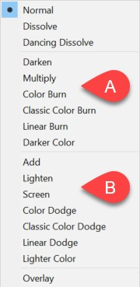
- Use the diagram to indicate which group of blend modes blend layers in a way that either “Lightens” or “Darkens” the combination of layers.

Name
A.
B.

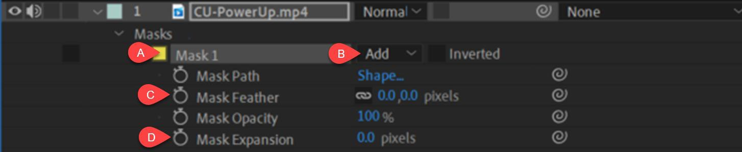
- Use the diagram above to explain the function for each of the mask controls.
Description
A.
B.
C.
D.

