After Effects Project 11 S.E.T.
cenario: DJ Jewell loved your composites from the last project so much that she has wants you to use a music clip
S
to animate a new composite that is synced to the sound.

xpectation: Learn how to animate text along a path and tie your animation to sounds.
E
T imeline: This should take you 1-2 hours of class time to complete.

PASTE YOUR TEST RESULTS HERE

After Effects Project 11 Worksheets
NOTES: Using the BrainBuffet Project 11 tutorials, please answer the following questions.

- What two tools can you use to create a path for the text to follow? a.
b.
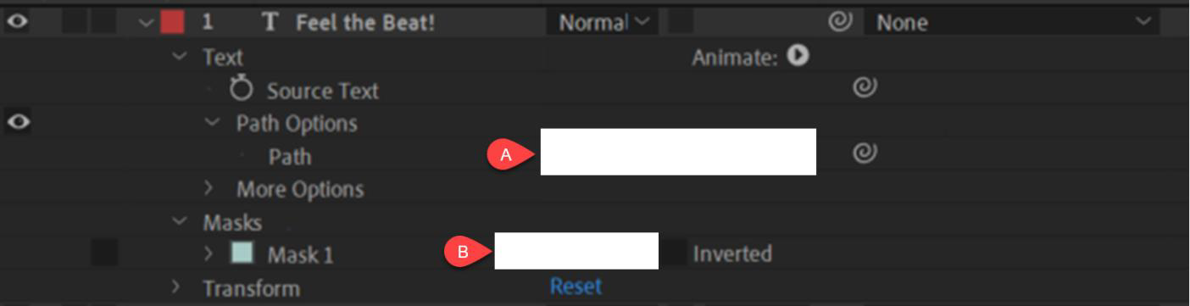
- Fill in the value for each of the white boxes in the diagram above. a.
b.
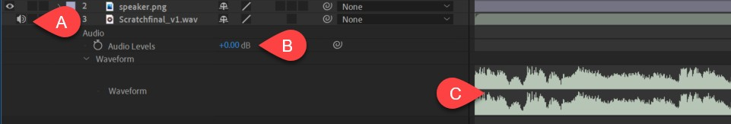
- Use the diagram above to name and describe the features that are unique to an audio layer
 | Name | Description
A.
B.
C.

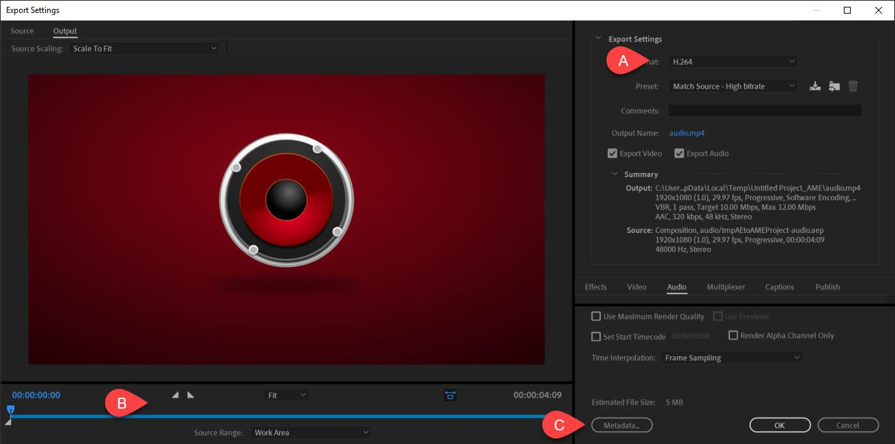

- Use the diagram above to describe the features in the Export Settings
 | Name | Description
A.
B.
C.

Make sure to export your text on a path video and place the video file in your project folder

