After Effects Project 12 S.E.T.
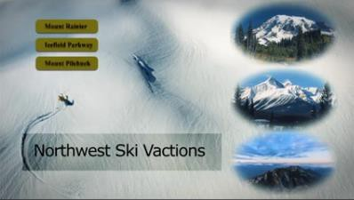
cenario: Northwest Ski Vacations has asked you to design an animated DVD menu with synced sound. This animation will
S
be the first thing people see when they start the DVD it is an important project for them. Their graphic designer will need a layered Photoshop file to work with so please export this as well.

xpectation: Learn how to organize your layers using the shy switches, use parenting and copy/paste to quickly apply
E
animations to multiple layers, additional ways to mask objects, work with adjustment layers and finally adjust and sync your animations to sound FX.
Timeline: This should take you 5-6 hours of class time to complete.
PASTE YUR TEST RESULTS HERE

After Effects Project 12 Worksheets
NOTES: Using the BrainBuffet Project 12 tutorials, please answer the following questions.

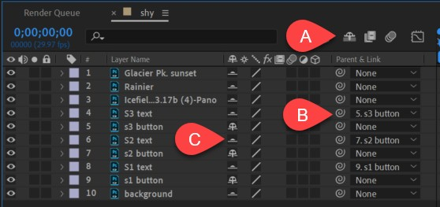
  - Use the diagram above to name controls
Name
A.
B.
C.

  - What is the best way to add an elliptical mask to an entire layer? a.
b.

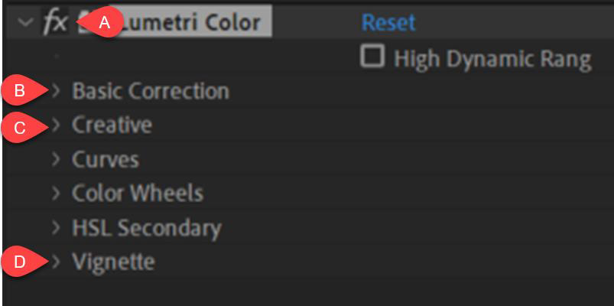
  - Use the diagram above to name controls
Name
A.
B.
C.
D

  - Add a screen shot of your shy layers and parenting to your project layer

