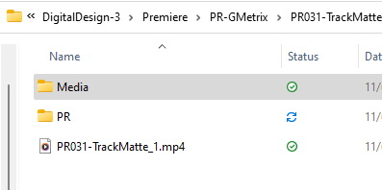
SETTING UP FOR SUCCESS
- Make a new folder called PR031-TrackMatte
- Create your Media and PR folders
- Copy and Paste your two movies from PR021-LJCut to your Media folder
- Copy and Paste a song to your Media Folder.
- Go to Cooltext.com and make an image with something that represents MHS
  - Color doesn't matter / use a "fat" font so you can see through it.
  - (MelHigh Bulldogs, Bulldogs, Melbourne, 'Dawgs, etc.)
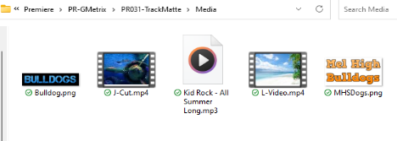
- Drag and drop the picture to your Media folder / rename the picture.
STARTING PREMIERE
- Open and Create a new Premiere project - NAME/LOCATION/SAVE
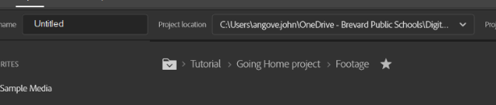
- Watch your videos, whichever has the least motion, put on Layer V1.
- Put your other video (with the most motion) on Layer V2.
- Put your CoolText Picture on Layer V3.
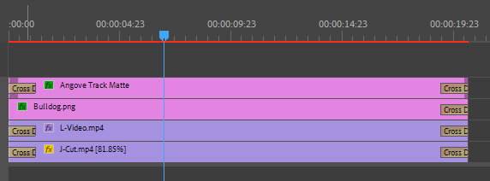
- Put your audio on the A1 Layer.
EDITING IN PREMIERE
- Make your videos (V1,V2) the same length (Use rate stretch tool to make one longer)
  - Maybe 10 seconds?
- Make your picture on V3 longer to match videos.
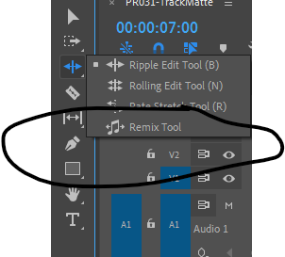
NEW TOOL AUIDO REMIX
- Using the Remix tool (Under ripple Edit tool) shorten your audio to match
- Listen to the music - especially the squiggly lines to see if it remixed it OK.
TRACK MATTE
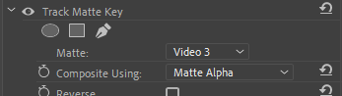
- Use track matte key on V2.
- Apply the track matte to V3 in effect controls
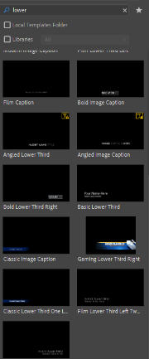
- Animate the V3 layer using scale tool to move in / out.
  - Maybe put a drop shadow on the v3 layer - see how it looks.
PUTTING YOUR NAME ON IT
- Apply a lower third with PR031-TrackMatte and your Name

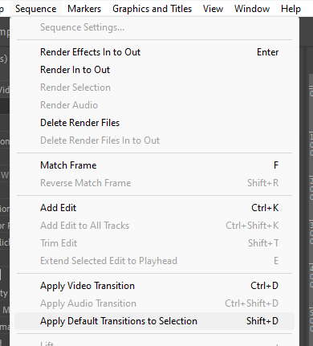
TRANSITIONS
- Select ALL your project then go to Sequence/Apply Default Sequence to Selection.
- **Remember this - I used this all the time!
- Oops - Your track matte messed up - delete one of the entry transitions until you make it look good.
EXPORT
- Export as 720P (1280X720) / post up on your website. 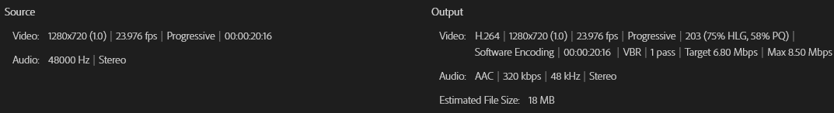
PUTTING ON YOUR WEBSITE / GETTING CREDIT
- Upload to your Google Drive in the Video/GMetrix folder
- Open your website and make section to put it in.
- Link your video up and do a short explanation of what you did.
- Publish your site.

