PR02-MOUNTAIN BIKE RUBRIC TO GRADE YOURSELF
UPLOAD TO FOCUS WHEN DONE – THIS ALSO SERVES AS A NOTICE FOR ME TO GRADE YOUR VIDEO
VIDEO | SUBJECT | POINTS | YOUR GRADE | TEACHER
Main Video – MultiCam Edit | 3-4 Cuts on video | 20
Main Video | No Ummms / Reduce Noise | 10
Speed Changes / Freeze Time Remap | Puddle Splash | 10
Speed Changes / Slow Time Remap | Slow Crash | 10
Lower Third  Box has Linear Gradient Effect | Animated with Box/Text | 20
Lower Third Tracking/Leading/Kerning | Text Close | 10
Audio Merge | Off Couch Ride | 10
Color Correction | Cable Cam | 10
Adjustment Layer | Black White | 10
Adjustment Layer | LetterBox | 10
Audio | Ducking Audio | 10
Credits Scrolling (Over Picture/Vid) | Credits End | 10
 |  | 140
Overall Look and flow of video  Video 3 Videos uploaded | Description of what learned | 60
TOTAL | Write YOUR totals | 200
LATE (-10%) (Over 1 Week -20%)
Screen Shot GMetrix lessons  ALL Green / Completed | 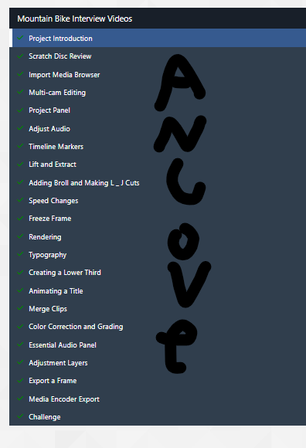
Folder Management PR  Should have Media and PR folders | 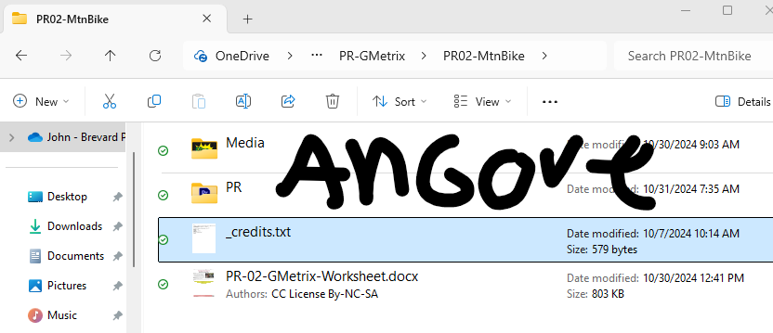
Premiere ScreenShot Folders  Should Include Media and Sequence folders | 