 | Take a screenshot of your finished timeline  (Should be colorful) | 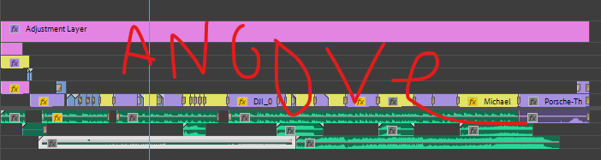
2. | Take a screenshot of your Track Matte  (You learned this in PR05-TrackMatte & PR04-Porsche – 6th video) | 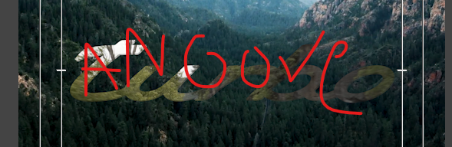
3. | Take a screenshot of Lumetri Coloring (make it noticeable)  (You learned this in PR04-ColorCorrection & Grading) | 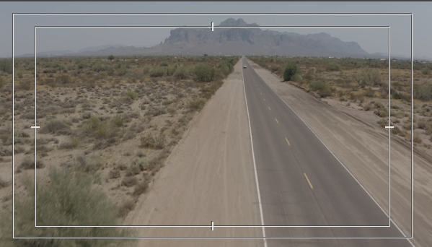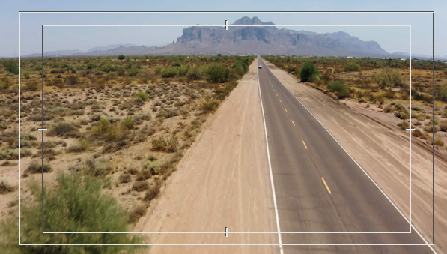
4. | Take a screenshot of your Blend Modes  (You learned this in PR05-BlendModes) | 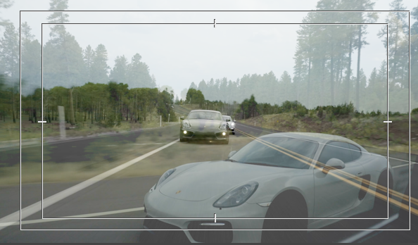  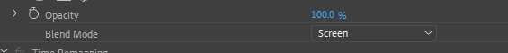
5. | Take a screenshot of your Adjustment Layer (I used Crop)  (You learned this in PR02-Adjustment Layers) | 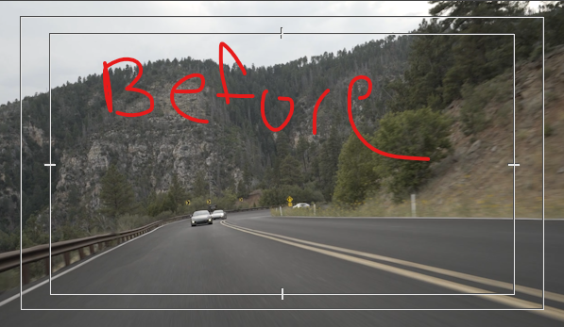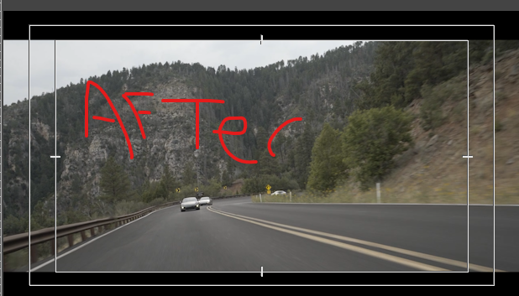  Notice the black top and bottom – like we did on PR03-Dirtfish
6. | Take a screenshot of your audio track  You should have:  1. Voices Soundtrack  2. Special Effects (SPX)  3. MusicLayer | I am looking for about 3 layers.  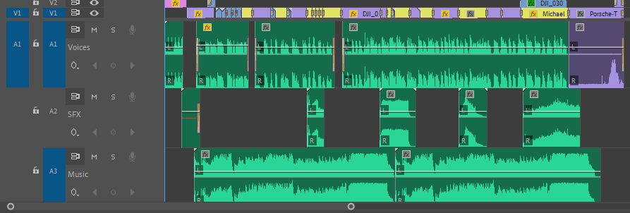
7. | Take a screenshot of the Audio Clip Mixer  (You learned this in PR01-Working with Audio)  I did not “duck” my audio – I reduced the volume of the music layer so the voices could be heard. | 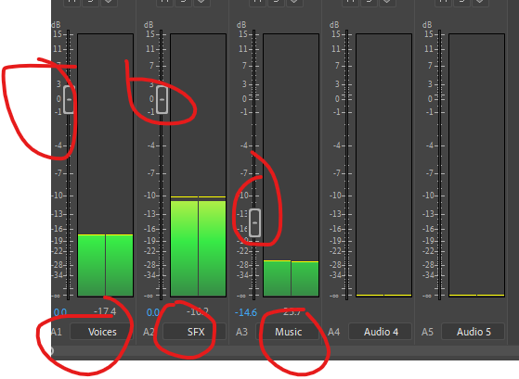
8. | BONUS  Take a screenshot of your ClosedCaptions

